Sanctuary Rose Window
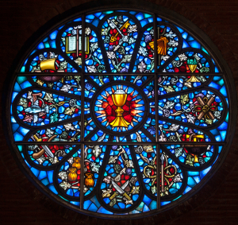
Rose Window – “The Martyrdom of the Twelve Apostles”
This unique Rose Window is entitled “The Martyrdom of the Twelve Apostles” and was created by the firm Whipple Mowbray of Exeter, England. It was dedicated on March 25, 1973, and reflects the Gospel according to St. Mark (10:38), “Can you drink the cup that I must drink, or be baptized with the baptism with which I must be baptized?”
The composition has twelve symbols around a central symbol. The outer twelve symbols often refer to legendary events. These symbols are used correctly and allow me to read the story embedded in the window.
At a high level, the twelve symbols at the outer radius of the window are for each of the Twelve Apostles of Jesus. In the center of the window is the Cup of Christ.
Central Symbol, the Cup of Christ. Chalice and wafer against a red backdrop. It would be possible to read this element as a reference to Holy Communion. Because of the overall context of the window and the red backdrop I understand the center of the window as the Cup of Christ, that is, the agony which Jesus endured for us.
The cup being referred to is the cup Jesus mentions in Matthew 26:39 (Mark 10:38) during His prayer in Gethsemane. (See Psalm 75:8, Isaiah 51:17 and Jeremiah 25:15-17).
Twelve vines with fruit flow out from the central Cup of Christ symbol to the outer 12 symbols. The red backdrop behind each of the 12 outer symbols also helps to connect the outer symbols with the central symbol. (“I Am the True Vine”, and Matthew 20:23 “You will drink my cup…”)
Each pigment was fired into hand-blown glass. Most pigments were English; however, some French and German pigments were also used. The leading is ½ inch lead cams and the frame is of a burnished stainless steel.
This Rose Window is dedicated to the loving memory of Mr. and Mrs. John S. Culbertson and their son Dr. John S. Culbertson and given to All Saints’ Episcopal Church by their children, grandchildren and the wife of Dr. John S. Culbertson. As we grow as a parish, let us remember this fitting memorial to those who helped the mission church of Our Savior to become All Saints’ Episcopal Church.
The following letter was received from Kerry and Nancy Pierce on April 4, 2015:
My wife and I live in Edmonds, Washington. Our daughter Kirsten attends George Fox University in Newberg, Oregon.
We attend Maple Park Church in Lynnwood, Washington. It is a Lutheran Brethren Church. I grew up in the home of a fine ELCA Lutheran Pastor.
My passion is art (I worked at Will Vinton Studios in Portland for about six years). My other passion is Christian Education. I like to put the two together whenever possible.
Yes, I read about the rose window on your website while I was doing research for an Adult Discipleship class I was teaching.
Your window is very beautiful, but it also has a theme that I have not seen in a window of this type. The story it tells causes me to reflect deeply on my faith.
Kerry did a 19 Part Blog on the All Saints Rose Window. It can be found below:
The Cup of Christ—Part 1
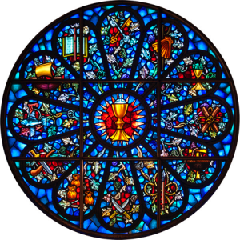
A quick review before we begin. Symbols are a shared visual language in a culture. As we have seen in the previous stained-glass windows, Christians also have a unique set of symbols which serve us as a common language. For Christians, the beauty of Christian Symbolism is that it is universal. It cuts across time, culture, denominations, etc.
Having an understanding of Christian symbolism allows me to understand a statement that was so important to the people at a particular church that they embedded it permanently into their architecture. It doesn’t matter that the window was made 150 years ago in a different country. It doesn’t matter that the congregation is Lutheran, Anglican, Catholic, Presbyterian, Episcopal, Methodist, etc.
We all point to Christ. This is good.
We move to a very special window in All Saints Episcopal Church Portland, Oregon. This is a modern window with a different theme than we have seen before. More than any window we have reviewed to date, this Christian Mandala causes me to reflect on Christ and what He has done for me.
The Cup of Christ—Part 2
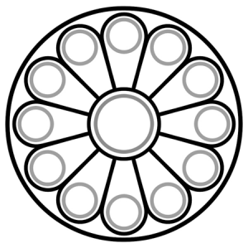
In part 2, I will begin to unpack the meaning of this window. Because of its importance, we will spend some time on this study.
The All Saints Episcopal Church window is beautiful. This mandala incorporates lesser known Christian Symbols. Careful research went into the creation of this window.
The line drawing I’ve included shows the overall structure of the window. There are twelve symbols around a central symbol. The outer twelve symbols often refer to legendary events. (I will expand on this in future posts.) These symbols are used correctly and allow me to read the story embedded in the window.
At a high level, the twelve symbols at the outer radius of the window are for each of the Twelve Apostles of Jesus. In the center of the window is the Cup of Christ.
The Cup of Christ—Part 3
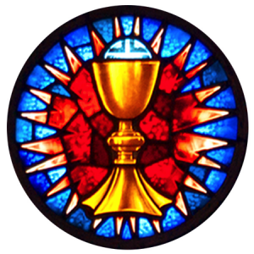
In part 3, we focus on the Cup of Christ.
In the center of the All Saints Episcopal Church window is the Cup of Christ. We see a chalice and wafer against a red backdrop. It would be possible to read this element as a reference to Holy Communion. Because of the overall context of the window and the red backdrop we are intended to read the center of the window as the Cup of Christ, that is, the agony which Jesus endured for us. This was a willful act of obedience on the part of Jesus.
The cup being referred to is the cup Jesus mentions in Matthew 26:39 during His prayer in Gethsemane. Jesus’ last words at his arrest recorded in John 18:11 refer again to the cup. This cup is God’s righteous judgment and punishment for sin, which Jesus obediently took on for the world. (See Psalm 75:8, Isaiah 51:17 and Jeremiah 25:15-17).
For Jesus, on a surface level, the cup will manifest itself as mocking, scourging, and crucifixion for us. It goes deeper. For Jesus, the cup goes to a level that I cannot fully comprehend. A sinless Jesus was being made to be sin for us (2 Corinthians 5:21). It caused him to cry out: “My God, my God, why have you forsaken me?” This was hell.
Sometimes I simply sit and think on what Jesus has done for me.
In part 4, we begin to move out to the twelve Apostles beginning with the brothers James and John whose lives end in very different ways.
The Cup of Christ—Part 4
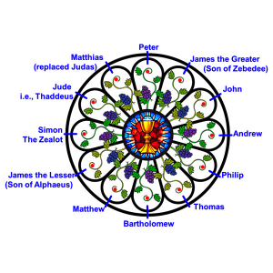
Twelve vines with fruit flow out from the central Cup of Christ symbol to the outer twelve symbols in the window. The vines call to mind Jesus’ statement: “I Am the True Vine”. The red backdrop (red dots in the figure) behind each of the twelve outer symbols also helps to connect the outer symbols thematically with the central Cup of Christ symbol. (Matthew 20:23 “You will drink my cup…”)
My best take on the Twelve Apostles of Jesus is shown in the figure. Whoever created this window did a lot of careful research to incorporate the symbols for each of the Apostles. Note that a given Apostle may have more than one symbol to choose from in terms of representing him. For example, in the PLU window we saw Matthew represented as a winged man referring to Matthew’s role as a Gospel writer. Here Matthew is represented with three bags of money which refers again to Matthew the Apostle, but this time identifies Matthew by his role as a Tax Collector.
The symbol choices used for the Apostles vary in this window. Sometimes a common Apostle symbol is used, as is the case with Matthew, other times, an Apostle’s martyrdom symbol is used.
In part 5, we begin at 1 o’clock with the symbol for James the greater, the brother of John, and the first of the Apostles to be martyred. (I am excluding Judas).
The Cup of Christ—Part 5
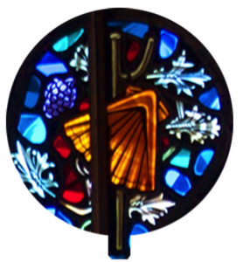
1 o’clock. Traveler’s staff and scallop shell. James the Greater, brother of John. The scallop shell was used for collecting drinking water, so the staff and shell are used here to represent someone who was on the road. Sometimes a sword and scallop shell is used for James.
Note on James. James was the first of the disciples to be martyred between 42 and 44 AD. Acts 12:2. One tradition is that he traveled to Spain and established the church there and then returned to Judea. Therefore, James becomes the patron saint of Spain. Others, Matthew Henry for example, contend that James never left Jerusalem. As is the case with some of the other Apostles, their martyrdom is based on tradition and the associated symbols in this window synch-up with that tradition. Regardless, the symbol used here is the symbol for James the Greater and he was martyred according to Scripture.
In part 6, we move to John, the brother of James the Greater at the 2 o’clock position.
The Cup of Christ—Part 6
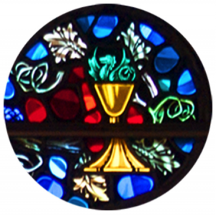2 o’clock. Snake and chalice. John, the brother of James the Greater, the son of Zebedee and Salome, and known also as one of the sons of thunder. Tradition holds that John was the one apostle to live to an old age and not die a martyr’s death. John is most often symbolized as an Eagle referring to his role as the likely writer of the Gospel of John. The symbol used here refers to the tradition that enemies gave John a poisoned cup of wine to drink. Another possible explanation of the symbol comes from Matthew 20:23 where Jesus says to John: “You will drink my cup…”
There is a pretty intense painting done by the Spanish artist Alonzo Cano entitled Saint John and the Poisoned Chalice. It captures the moment. You can find it under Alonzo Cano on Wikipedia.
In part 7, we move to Andrew at the 3 o’clock position.
The Cup of Christ—Part 7
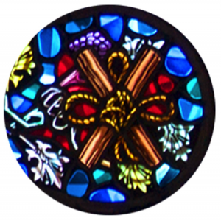
3 o’clock. Wood and rope. Andrew, the brother of Peter. It was Andrew who brought Peter to meet Jesus (John1:41-42). Traditional holds that Andrew was martyred by being tied to an X shaped cross and crucified.
The painting entitled The Crucifixion of St Andrew by the Italian painter Mattia Preti depicts the scene. Painters from the Baroque period are a good source of Christian imagery.
In part 8, we move to Philip at the 4 o’clock position.
The Cup of Christ—Part 8
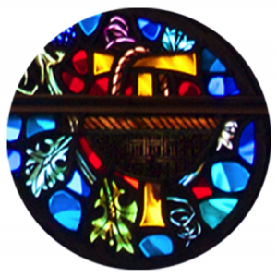
4 o’clock. Tau cross and basket. Philip. The basket refers to the feeding of the 5,000 in John 6. Details on Philip’s death are not abundant. The T shaped cross refers to one tradition that Philip was also crucified on a cross of this shape.
The painting entitled The Crucifixion of St. Philip the Apostle by the Flemish painter Jan van de Venne depicts the scene.
A 500-year-old print by the German printmakers Michael Wolgemut and Wilhelm Pleydenwurff depicts another tradition that Philip was both stoned and crucified on a T shaped cross. It is titled: The Crucifixion and stoning of Saint Philip.
In part 9, we move to Thomas at the 5 o’clock position after an Interlude.
The Cup of Christ—The Interlude
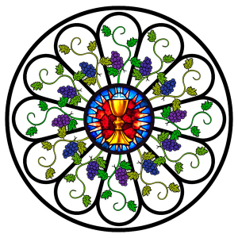If you find yourself in Portland, Oregon on a Sunday morning, consider stopping by All Saints Episcopal Church for worship. Why Kerry?
First, it is a place where you can spend time with God.
Second, the Rose Window in the sanctuary. The window I have been blogging on. This time of year the light from the morning Sun is transformed as it journeys through the window into the sanctuary. The window is alive. The glass takes a hold of the light. The red and gold elements crackle against the blue and green background.
I can blog about the window and understand it intellectually, but seeing the window is an entirely different experience.
Third. The People. We arranged for a visit with Chuck, the senior warden, Friday morning at 10:00. We arrived early and were welcomed into the church by Nancy.
Nancy was beginning preparations for a hot lunch for the local community. Over 100 meals would be served on Saturday. To listen and watch Nancy and the others you would think she was going to make a Thanksgiving dinner for her family. She was.
Chuck arrived at 10:00 and met us along with a half a dozen others including Laura, the Rector of All Saints Episcopal Parish. Like Nancy, these people are full of grace, and a love for Christ, community, and their Church. They spent more than eighty minutes showing us their window, organ, furnishings, altar coverings, and their special love for their home. They treated us in the same way that Nancy thought about the community she would feed the next day.
The Cup of Christ—Part 9
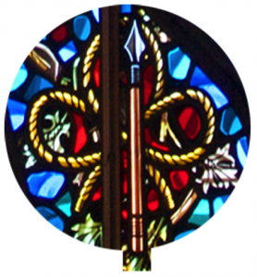
5 o’clock. Spear and rope. My best guess is Thomas, who is often referred to as doubting Thomas. The tradition is, that Thomas eventually traveled to India to spread the Gospel. The spear refers to Thomas’ martyrdom by being run through with a spear. While the spear definitely fits with Thomas, I am not clear about the rope with its three loops. In the context of the window a three looped rope motif is used in Andrew’s symbol indicating that he was bound by rope during his martyrdom. I don’t have any sources or artwork examples to support the binding of Thomas during his martyrdom.
The only element I have art and legend for that connects Thomas to a rope is a cincture. A cincture is a rope-like belt or cord worn over clothing. It could be used to gird up one’s loins, so to speak. Notice how the rope in this panel is finished off at the ends. The legend, which is depicted in art, is that the Virgin Mary lowered her cincture from the sky to convince doubting Thomas that she had ascended to heaven. Possible, but not a fully compelling explanation of the rope element in the symbol.
The painting entitled The Martyrdom of Saint Thomas by Rubens depicts Thomas’ martyrdom. Rubens is very recognizable, and again, the Baroque Era is really good for capturing the intensity of these scenes.
In part 10, we move to Bartholomew at the 6 o’clock position.
The Cup of Christ—Part 10
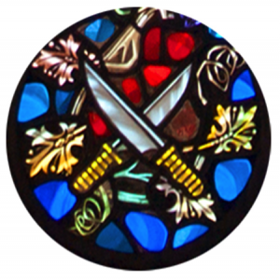6 o’clock. Knives. Bartholomew (also likely named as Nathaniel). The tradition is that Bartholomew was flayed and then crucified. In Michelangelo’s painting of the Last Judgment in the Sistine Chapel, Bartholomew is the apostle holding his own skin. Ouch.
Hold on Kerry. Are these guys that you are blogging on, the same guys that left Jesus during his arrest in Gethsemane and ran like frightened schoolboys? (Mark 14: 50)
Yes, they are.
So now they are heroes of the faith standing up for Christ to the point of martyrdom? This is a rather amazing transition.
Yes, it is. So, what caused their rapid spiritual growth spurts?
Some pretty substantial events took place after the crucifixion. These include, but are not limited to: The Resurrection, the post-Resurrection Appearances of Christ, and Pentecost. For me, seeing a risen Christ, and yes, perhaps sticking my finger into his side, together with the indwelling and work of the Holy Spirit would dramatically accelerate my faith. Simply reading and reflecting on these events grows my faith.
Would I run off at the first sign of trouble? Jesus asks this question in a much deeper way in Mark 10:38: ³⁸ Jesus said to them, “You do not know what you are asking. Are you able to drink the cup that I drink, or to be baptized with the baptism with which I am baptized?” I will discuss this text and answer the question above throughout the remainder of this blog.
Besides the depiction in Michelangelo’s Last Judgment, The Martyrdom of Saint Bartholomew is also rendered in a more palatable form by the Spanish artist Jusepe de Ribera. The fully clothed figure in the center sharpens a knife in the dark area below his right shoulder. Again, this is from the Baroque period.
In part 11, we move to Matthew at the 7 o’clock position.
The Cup of Christ—Part 11
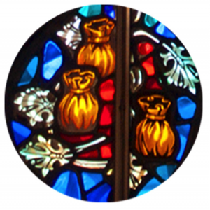7 o’clock. Three bags of money. Matthew the tax collector. As mentioned earlier, Matthew, like many of the apostles, is represented in art by a number of different symbols. The winged man is use to represent him as a Gospel writer. Here, three bags of money are used to represent him as the apostle who was a tax collector.
I cannot find a clear account for Matthew’s martyrdom. My favorite painter from the Baroque period, Caravaggio, depicts The Martyrdom of Saint Matthew showing the use of a sword. It is an impressive piece of art from a master.
Baroque. Paintings from the Baroque period are intense. The lighting generally has one strong light source with very little fill lighting. The result is contrast, highlights and deep shadows. Typically the scene captures a moment of drama, intense emotion, or movement. The Baroque style fits well with the martyrdom theme.
In part 12, we move to James the Lessor at the 8 o’clock position.
The Cup of Christ—Part 12
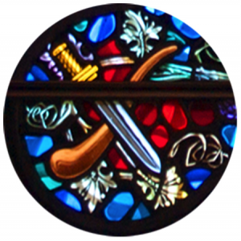8 o’clock. Fuller’s club and sword. James the Less, son of Alphaeus. Having ‘the Less’ appended to your first name feels painful. Apparently our second James was given this title either because he was short in stature, or younger than James the son of Zebedee.
James is tough to pin down due to the abundance of other folks named James, including James the brother of Jesus, and James the author of the epistle. There are arguments for and against these all being the same man.
It follows that there are various traditions on how James the Less was martyred. Scenarios change and permutate depending on whether or not this James is identified with any of the other James’ noted above. The most dramatic tradition was that one of our collective James was thrown from the temple mount in Jerusalem, then stoned, then beaten with a fuller’s club, and then finally cut in half.
A fuller’s club was used in cloth-making. An example is shown in the mural: The Martyrdom of James the Less.
In the next part we will take a breath and reflect on Rahab. Afterwards, in part 13, we move to Simon the Zealot at the 9 o’clock position.
The Cup of Christ—Rahab’s Habit
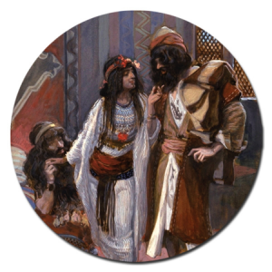We have gone through eight of the apostles. I have focused on their martyrdom and given links to dramatic depictions from Baroque art. Apostle after apostle.
Christian or non-Christian; mature Christian or just beginning your walk with Christ; you ask yourself questions about what happened to the Apostles: Why would I sign up for this? Is this a Christian’s idea of a good time? What would I do under the same circumstances? Does Jesus intend for me to undergo similar treatment?
James the Greater and his brother John ask Jesus a question. Jesus answers in Mark 10:35-40:
³⁵ And James and John, the sons of Zebedee, came up to him and said to him, “Teacher, we want you to do for us whatever we ask of you.” ³⁶ And he said to them, “What do you want me to do for you?” ³⁷ And they said to him, “Grant us to sit, one at your right hand and one at your left, in your glory.” ³⁸ Jesus said to them, “You do not know what you are asking. Are you able to drink the cup that I drink, or to be baptized with the baptism with which I am baptized?” ³⁹ And they said to him, “We are able.” And Jesus said to them, “The cup that I drink you will drink, and with the baptism with which I am baptized, you will be baptized, ⁴⁰ but to sit at my right hand or at my left is not mine to grant, but it is for those for whom it has been prepared.”
The eleven apostles with the addition of Matthias did drink the cup that Jesus drank. Inspired by the resurrection and the Holy Spirit, they faithfully lived out the will of God, in most cases, to the point of martyrdom.
But what about us? What do we learn from the All Saints window? Let’s look at two different answers beginning with Stephen Covey.
Stephen Covey wrote a book called The 7 Habits of Highly Effective People. First published in 1989 it is a classic in the business world. The basic premise is that there are universal principles that govern human effectiveness. They are in essence natural laws that cannot be broken without causing us to become less effective. If you align your values with these principles, you will be more effective. Lots of folks in the business world improved their careers by applying this book to their lives.
The second habit of the seven habits is to: Begin with the end in mind. Stephen writes: “Although Habit 2 applies to many different circumstances and levels of life, the most fundamental application of ‘begin with the end in mind’ is to begin today with the image, picture, or paradigm of the end of your life as your frame of reference or the criterion by which everything else is examined.”
As part of this habit you are asked to go through an exercise where you consider what family, friends, co-workers, and community would say about you at your funeral. By reflecting on this you gain an understanding of what the center of your life is. In other words, what is your main focus in life: Money, work, possessions, pleasure, family, etc.? Once that is understood, the goal is to move your central focus to a principle centered paradigm. In other words, your center should be focused on things like fairness, honesty, excellence, growth, etc. Doing this will lead to a more balanced and effective life.
I read the book 1994. I was rising quickly through the ranks of management in Silicon Valley and making a lot of money. When I did the habit 2 exercise, I discovered I was off the scale work focused. Disillusioned, I quit my job and began a slow journey to Christ.
For me, if I do the funeral exercise while looking at the All Saints window, I am not real excited about beginning with the end in mind. I do not want to wake up tomorrow and picture myself being martyred. It doesn’t work for me.
My guess is that it wouldn’t have worked for the Apostles either. Yet these men were chosen by Jesus to begin the Great Commission. They must have been highly effective in spreading the gospel. What was their center? What image did they hold in their minds?
A different habit is given in Hebrews 11. Hebrews 11 is sometimes called the honor roll of the Heroes and Heroines of Faith. Included in the list are Abel, Enoch, Noah, Abraham, Sarah, Isaac, Jacob, Joseph, Moses, Rahab the Harlot, Gideon, Barak, Samson, Jephthah, David, Samuel, the prophets, those persecuted and martyred.
Part way through the honor roll, the author of the Book of Hebrews writes in chapter 11:
¹³ These all died in faith, not having received the things promised, but having seen them and greeted them from afar, and having acknowledged that they were strangers and exiles on the earth. ¹⁴ For people who speak thus make it clear that they are seeking a homeland. ¹⁵ If they had been thinking of that land from which they had gone out, they would have had opportunity to return. ¹⁶ But as it is, they desire a better country, that is, a heavenly one. Therefore, God is not ashamed to be called their God, for he has prepared for them a city.
These men and women looked forward to the City of God, the heavenly Jerusalem, the place Christ is preparing for us. Their focus was not on the end. Their focus was on a new beginning with their Lord. They lived out lives of faith and obedience focused on that new beginning knowing that God had something better for them.
The author of Hebrews writes at the beginning of the same chapter:
11 Now faith is the assurance of things hoped for, the conviction of things not seen. ² For by it the people of old received their commendation.
Let’s look at Rahab the Harlot. Yes, having, the harlot, appended to your first name makes the name James the Less not feel quite as bad. Rabab would have failed the actual funeral exercise of Habit 2. The Jericho community and her Canaanite friends would have said something on the order of: “That manipulative harlot lied and sold us out to a couple of spies. Because of that filthy woman most of us died in the conquest of Jericho. May she ever be remembered as a prostitute.”
Rahab believed in the God of Israel despite the difficult situation and responded. Her faith was oriented towards the future and she demonstrated it by welcoming Joshua’s spies and, at risk, hid them saying in Joshua chapter 2:
¹¹ “…for the Lord your God, he is God in the heavens above and on the earth beneath.”
To her, the victory at Jericho was a foregone conclusion. Her faith in the God of Israel caused her to behave as she did. She received Divine approval for her faith.
But there is more to Rahab the Harlot. Far from being textbook Stephen Covey habit 2 approved, Rahab made the list of the heroes of Faith in Hebrews 11. She is mentioned in the same breath as Abraham and Moses. Rahab is also mentioned in the book of James. And even more profound, she is mentioned at the beginning of the book of Matthew in the genealogy of Jesus.
Rahab, like the Apostles we are reviewing, had eyes of faith that saw beyond the end to something better in the new beginning.
By faith, Rahab began with the beginning in mind.
Similarly, the Apostles often did not get approval from earthly rulers and tradition holds that in many cases their lives ended painfully as a result. The Apostles, by faith, did receive approval from a Divine source.
The image shown is a portion of a painting entitled The Harlot of Jericho and the Two Spies by James Tissot.
In part 13, we move to Simon the Zealot at the 9 o’clock position.
The Cup of Christ—Part 13
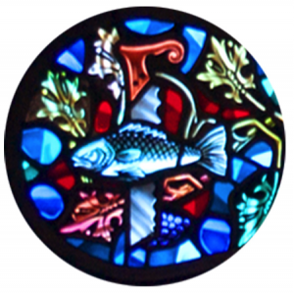9 o’clock. Saw and fish. Simon the Zealot. Known as a relentless fisher of men and believed according to one tradition to have been sawn in half.
The scene is depicted in the gruesome fresco: The Martyrdom of Simon the Zealot.
We come across some interesting names: James the Greater, James the Less, Rahab the Harlot, and now Simon the Zealot. We understand greater, less and harlot, but what’s a Zealot, or more appropriately, why is Simon referred to as Simon the Zealot?
There are two explanations. First, Simon had great zeal for Jewish law and was very passionate about his work. The second explanation is that Simon was connected with the Zealots, a group of Jews who believed in military rebellion against the Roman Empire. In other words, this group sought to remove the Roman Empire from the Holy Land by force.
Well respected theologians come down on both sides of the explanation.
For interest, let’s assume that Simon was a militant revolutionary Zealot. In our band of twelve apostles we also have Matthew. Matthew the Tax Collector. Matthew is essentially collecting taxes from his own people, giving the money to the Roman government and becoming wealthy in the process. Matthew is something of a traitor to the Jewish community.
These two men, under normal circumstances, would not have played nicely together.
Frederick Dale Bruner states in his commentary on Matthew: “A Zealot was as far removed from a tax collector as a leftist guerilla is from a right-wing conservative.”
William Barclay states in his Matthew commentary: “The plain fact is that if Simon the Zealot had met Matthew the tax-gather anywhere else than in the company of Jesus, he would have stuck a dagger in him.”
That Jesus could put these two men together and use them to help bring about His Kingdom speaks of a very strong leader, someone who could unite Simon and Matthew for a higher purpose.
In part 14, we move to Jude at the 10 o’clock position.
The Cup of Christ—Part 14
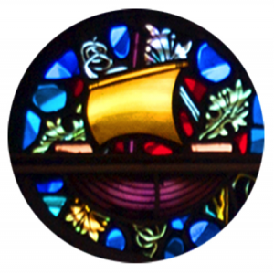10 o’clock. Sailboat with cross shaped mast. Jude also called Thaddeus or Lebbaeus. The tradition is that Jude traveled widely, and that he was martyred by being clubbed to death.
The scene is depicted in another gruesome fresco: The Martyrdom of Jude Thaddeus.
In part 15, we move to Matthias at the 11 o’clock position.
The Cup of Christ—Part 15
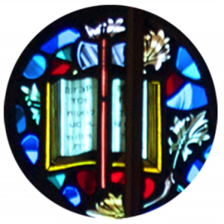11 o’clock. Hatchet and book. Matthias, who replaced Judas (Acts 1). Tradition holds that he was beheaded or first stoned and then beheaded.
The scene is depicted in The Martyrdom of Saint Matthias.
When the twelve disciples are portrayed together (excluding the Last Supper), Matthias is often used instead of Judas as we see in this window.
In part 16, we move to Peter at the 12 o’clock position where we will spend some time visualizing Peter through the eyes of a master.
The Cup of Christ—Part 16
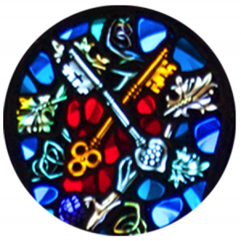12 o’clock. Keys. Peter. This symbol refers to Matthew 16:18-19.
¹⁸ “And I tell you, you are Peter, and on this rock, I will build my church, and the gates of hell shall not prevail against it. ¹⁹ I will give you the keys of the kingdom of heaven, and whatever you bind on earth shall be bound in heaven, and whatever you loose on earth shall be loosed in heaven.”
Peter is believed to have been crucified upside down.
The scene is depicted in the Crucifixion of St. Peter by Caravaggio. This painting from the Baroque period is beyond amazing. (See link above.)
Born in the Sixteenth Century, Caravaggio was a bit of a rock star. He was perhaps the most famous painter in Rome for a period while at the same time amassing a police record. He died while still in his thirties.
He was a brilliant artist. His rendering of surfaces was exceptional. The facial expressions of his subjects could be used as a textbook on human emotion. These capabilities are only part of what Caravaggio uses to create the drama and mystery we see in the Crucifixion of Saint Peter.
The scene is paired down to become very minimal. The normal crowds and landscapes are gone or have fallen entirely into shadow.
We see four men with the spotlight on Peter. There are three executioners. The executioner dressed in green (dark green in some images) strains to raise Peter with a rope. A second in red assists. The third in a muted gold color heightens the drama. In the spotlight with Peter, the third executioner has just dug a hole for the cross to rest in. The shovel is still in his hands and his feet are covered with dirt. The muscle forms in his lower right leg flex as he strains to lift an old, but still very physical Peter. His rear end comes out of the frame of the painting into our reality. We feel gravity and mass in this image.
Peter is fully lit from above with two small shadows falling across his body causing his feet and his knees to become pronounced. The affect is that these portions of his body also appear to break out of the frame and enter into our world. His feet and his left hand have large spikes going through them attaching his body to the cross. Only the tiniest suggestion of blood is introduced.
The facial expression of Peter is the high point of the image. This is no longer the young, hot blooded apostle who cut off the ear of the High Priest’s servant. The mature Peter here looks introspective and reflective. One pauses at this point to consider what Peter is thinking. Is he reflecting on what Jesus went through? Is he thinking of work for the Kingdom that he has left unfinished? Or perhaps his thought is that he will soon join Christ again in a new reality.
In part 17, we conclude.
The Cup of Christ—Part 17
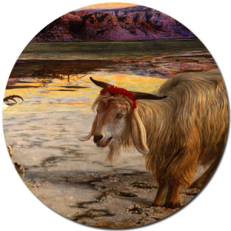The All Saints Episcopal Church mandala causes me to reflect on three major themes: First, what Jesus went through in order to accomplish his work. Not just the physical scourging and crucifixion, but one who was sinless was made to be a sin offering (2 Corinthians 5:21). That Good Friday was my Day of Atonement. Christ was the final blood sacrifice for sin. It is finished and through that work I am given access to God.
Twelve vines with fruit flow out from the central Cup of Christ symbol to the twelve apostles.
I next consider the transformation of these Apostles who fled and denied Jesus and later died for their faith. Their experience of the resurrected Christ and their experience at Pentecost changed them. Inspired, they began their work and became heroes of faith by obediently keeping the Great Commission and abiding in Christ.
Finally, I reflect on my own responsibility. I am a living part of the greatest transaction in history. My sins have been transferred to Christ, he owned them and took the punishment, and his righteousness has been imputed to me. My work is to obediently live out the faith God has called me to as I embrace Christ and allow him to sustain me.

